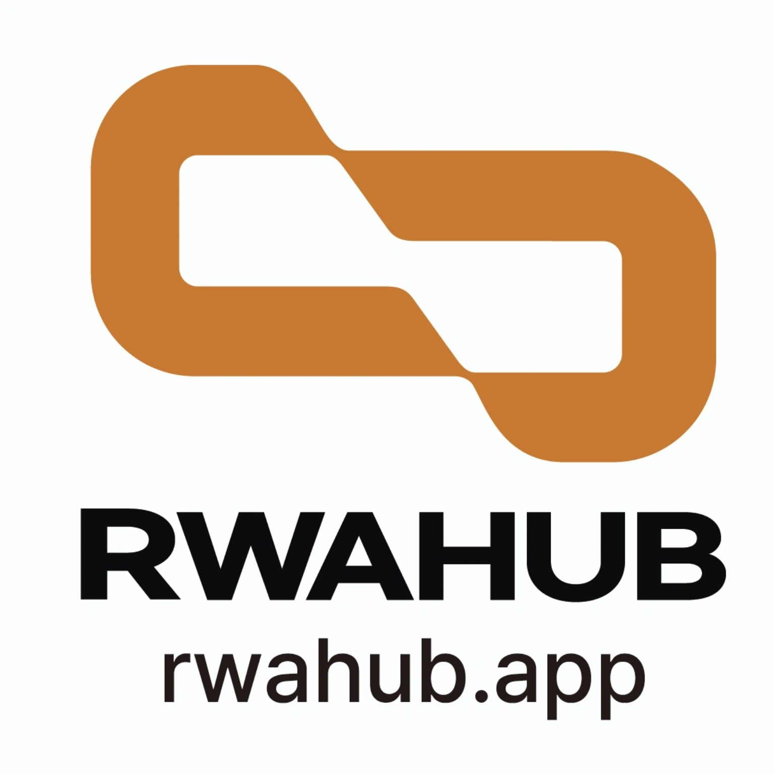

DATACITYWEMARKET CO., LTD.
RWAHUB COMPANY PROFILE
RWA · Utility Token · OTA · Entertainment · Global Digital Asset Ecosystem

Real World Assets × Blockchain × AI × Web3
www.rwahub.app
September 2026

1. Company Overview
DataCityWeMarket Co., Ltd. aims to become a global platform company connecting RWAHUB, a utility-token ecosystem, OTA, and entertainment businesses, with the goal of digitizing and globally distributing real-world, financial, cultural, and intellectual-property assets. Its RWA business adopts a hybrid model combining centralized (CeFi/regulated) and decentralized (DeFi/on-chain) structures according to asset characteristics and applicable jurisdictional regulations.

2. Vision and Core Strategy
“Connecting Real-World Assets to the Global Digital Economy.”
- Develop RWAHUB into a global RWA infrastructure platform connecting the real economy with digital finance.
- Build an integrated digital-asset ecosystem combining RWA, Web3, DeFi, AI, and OTA.
- Expand sustainable real-world utility by linking revenue, users, and cash flows from operating businesses with the token ecosystem.
- Pursue a global hybrid strategy combining jurisdiction-specific regulated channels with DEX/DeFi structures where legally permitted.

3. Corporate Structure and Roles
Entity / Business | Core Role
DataCityWeMarket Co., Ltd. | Group strategy, governance, investment, brand management, global business management, and planned transition toward a holding-company structure.
RWAHUB | RWA registration, structuring, tokenization, distribution linkage, multi-token operations, and AGOS-based risk management.
Utility Token Ecosystem | Real-world utility across OTA, performances, carbon/ESG, beauty, and entertainment.
Global OTA | Integrated distribution of accommodation, travel, aviation, performances, tickets, and experiences; Delaware U.S. headquarters planned.
Entertainment | K-POP, K-Culture, performances, content, and IP businesses.
Project SPVs | Country- and project-specific execution for real estate, smart farms, mines/resources, content, and other assets.
Swiss Foundation | Planned Swiss foundation serving as an overseas base for the global RWA and Web3 ecosystem.
Note: Actual equity ownership, legal relationships, foundation structures, and overseas entities will be finalized based on corporate registrations, contracts, tax documentation, and applicable regulatory review.

4. CEO Profile
Jang Jinwoo | Chairman of the Board, DataCityWeMarket Co., Ltd.
RWAHUB Founder & Chairman
Education & Academic Experience
- Yonsei University, Graduate
- Yonsei University Graduate School of Business, Graduate
- Former Adjunct Professor, Kyung Hee University
Professional Experience
- Hanjin Group - Corporate Planning Office / Information Systems Coordination Office
- Founded and operated 3W Tour, an early Korean internet travel agency, in 1996
- Chief Executive Officer, Zion International, Singapore
- Chief Executive Officer, 3W Group
- Chief Executive Officer, E-Academy Holdings
- President & Executive Director, School Land
- Head & President, International English Village Business Group
- Head, Adult English Education Center affiliated with Korean Minjok Leadership Academy
- Vice President, HIFA Development Co., Ltd.
- Chief Executive Officer, LUX Co., Ltd.
- Head of Corporate Management, All IT Group
- Chief Executive Officer & General President, CP King Korea Co., Ltd.
- Chairman, Global B2B Partnership Forum
- Chairman, White Dia Korea Co., Ltd.
- Chairman of the Board, DataCityWeMarket Co., Ltd.
- Oversees the RWAHUB real-world asset tokenization platform business
Major Awards
- Korea's 13 Shining Leaders
- Patent News Blockchain Grand Prize
- Challenge Korea Blockchain Grand Prize
Note: Before external distribution, academic background, career history, award titles, dates, and organizers should be finally verified against supporting documentation.

5. Core Business Models

5.1 RWA - Hybrid Centralized and Decentralized Asset Tokenization
Legal rights, custody, valuation, cash flows, and investor rights relating to underlying assets are confirmed off-chain, while blockchain-based registration, issuance, transfer, settlement, and DeFi linkage are implemented where permitted by applicable law. RWAHUB is designed around a Multi-Token structure that separates the Main Token from asset-specific Sub-Tokens and uses AGOS (AI Governance Operation System) to manage valuation, collateral, market, and regulatory risks by asset.
Asset Class | Primary Areas
Art / Cultural Assets | Artworks, collectibles, and cultural assets
K-Culture / Entertainment | K-POP, performances, content, and music/video-related rights
K-Beauty / Bio | Cosmetics, beauty, biotech projects, and distribution assets
Real Estate | Income-producing real estate, hotels, resorts, and smart farms
Mining & Resources | Mines, metals, commodities, and resource-development projects
Corporate / Patent / IP | Patent-based companies, technologies, business rights, copyrights, trademarks, and licenses
Equities / Bonds | Tokenization structures related to listed/unlisted equities, government bonds, and corporate bonds
Carbon / ESG | Carbon-related assets and ESG data/services
Note: Equities, bonds, beneficial interests, and similar rights may be subject to securities or financial-product regulation regardless of token naming. Licensing, issuance, and distribution structures must therefore be designed separately for each jurisdiction.

5.2 Utility Token - Ecosystem Activation
- Payment, rewards, and membership linkage for OTA accommodation, travel, performances, and experiences.
- Performances, tickets, memberships, K-POP, content, and the broader entertainment sector.
- Carbon/ESG services and environmentally oriented ecosystems.
- K-Beauty products, memberships, and global commerce.
- Utility-focused design for partner rewards, service access, and platform fees.
The Utility Token is intended primarily for access to and use of products and services, rather than as a vehicle guaranteeing investment returns. Its legal classification will be reviewed separately in each jurisdiction.

5.3 Global OTA
- Secure differentiated long- and short-term accommodation inventory and build a global supply network.
- Connect accommodation, travel, aviation, performances, K-POP, and K-Beauty experiences within a unified platform.
- Performance OTA packages combining tickets, air/ground transportation, accommodation, and experiences.
- Research RWA-based financing structures for accommodation, resorts, and related assets.
- Integrate Utility Token payments, rewards, and memberships subject to applicable laws.

5.4 Performances and Entertainment
- Global K-POP concerts and festivals.
- Integrated K-Culture, beauty, fashion, and art events.
- Artist, composition, songwriting, video, and IP projects.
- Performance pre-sales, sponsorships, and brand partnerships.
- Global fan-travel products combining OTA and live performances.
- Separate RWA/ST and Utility structures according to the nature of rights and applicable regulation.

6. RWAHUB Platform Structure
Asset / IP Owner → Due Diligence → Valuation & Legal Rights → Custody / Trust / SPV → RWAHUB Tokenization Engine → CEX / Regulated Distribution or DEX / DeFi where legally permitted → Investor & User Dashboard → Settlement & Asset Management
- Multi-Token Onboarding connecting diverse RWA projects within a unified ecosystem.
- Integration of Smart Contracts, NFTs, Oracle, Wallet, and P2P functions.
- AGOS-based AI data analytics, auditing, anomaly detection, and risk management.
- Planned AI-based asset valuation, Cross-Chain, and DeFi integration.

7. Revenue Model
Business | Primary Revenue Sources
RWA | Structuring, registration, technology, management, and transaction/settlement-linkage fees
Utility Ecosystem | Service, membership, and platform usage fees
OTA | Accommodation, travel, ticket, package sales, and supplier commissions
Entertainment | Performances, tickets, sponsorships, IP, content, and merchandise
K-Beauty | Global vendor, distribution, commerce, and brand collaborations
Carbon / ESG | Gateway, dashboard, retirement, and data services
B2B / API | Enterprise RWA, ESG, payment, and data APIs

8. Corporate History and Global Roadmap
Period | Milestone | Details
2018 | Establishment of DataCityWeMarket Co., Ltd. | Established the foundation for blockchain and digital platform businesses.
2020 | Launch of Real-World-Asset-Based Blockchain Business | Initiated an international blockchain exchange development project based on Israeli diamond real-world assets.
2022 | Blockchain and Metaverse Technology Expansion | Launched the Metascience.com mainnet.
2023 | Entry into the Global Digital Asset Market | Listed on Singapore-based Coinstore and accumulated global digital-asset and platform experience.
2024 | Full-Scale Entry into RWA Business | Advanced regulatory/legal review, business-structure design, and RWA platform development.
2025 | Official Launch of RWAHUB | Built the Multi-Token Onboarding Platform and expanded target RWA asset classes.
2026 | RWAHUB Platform Advancement | Strengthened Multi-Token, Smart Contract, Oracle, Wallet, P2P, AGOS, AI, and DeFi capabilities.
2026 | Pionex Listing | Expanded RWAHUB's global distribution and Web3 ecosystem through listing on Pionex.
Q4 2026 | Global Corporate Structure - Planned | Plan to establish the Swiss RWAHUB Foundation and a Delaware-based U.S. OTA headquarters, while advancing DataCityWeMarket toward a holding-company structure.
Q1 2027 | Global Top-Tier Exchange Expansion - Planned | Plan to pursue listings on global top-tier digital asset exchanges, including Bybit.
2027 and Beyond | Global RWA Infrastructure Platform | Expand a global digital-asset ecosystem integrating RWA, Web3, DeFi, AI, and OTA.

9. Three-Phase Growth Roadmap
- Phase 1: Expand RWA asset classes, secure Utility Token use cases, and build OTA supply networks and performance businesses.
- Phase 2: Expand global partners, country-specific SPVs, institutional-investor relationships, K-Beauty, Carbon, and Entertainment.
- Phase 3: Prepare for global exchange and capital-market entry and establish an international RWA · OTA · Utility ecosystem.

10. Investment and Partnership Highlights
- Combination of multi-asset RWA, real-world Utility, OTA, and Entertainment.
- Connection between online asset finance and offline consumption/cultural ecosystems.
- Structure designed to serve both B2B asset suppliers and B2C global users.
- Hybrid strategy combining jurisdiction-specific regulated CEX/institutional channels with legally permitted DEX/DeFi.
- Linkage of operating-business revenue, users, and cash flows with the token ecosystem.

11. Global Objectives
- RWAHUB: Grow as the core platform and token of a global RWA ecosystem; following the Pionex listing, pursue listings on global top-tier exchanges, including Bybit, in Q1 2027.
- DataCityWeMarket Co., Ltd.: Advance toward a holding-company structure connecting RWAHUB, Utility Token, OTA, Entertainment, and overseas entities/foundations.
- Global OTA: Expand globally from the planned Delaware U.S. headquarters through an integrated model combining accommodation, travel, aviation, performances, K-Culture, and K-Beauty.

12. Important Notice
This company profile is provided for corporate introduction and business-strategy purposes only. It is not an investment solicitation, securities registration statement, or guarantee of exchange listing. It does not guarantee rights, investment returns, redemption, listing, liquidity, or appreciation in value of any tokenized asset. Each business will be implemented subject to review of applicable capital-markets, virtual-asset, electronic-finance, foreign-exchange, tax, consumer-protection, privacy, intellectual-property, and sector-specific laws in Korea and relevant jurisdictions. Future plans and exchange listings are subject to applicable review, legal, financial, governance, audit, liquidity, and disclosure requirements.

